MYLER USER MANUAL

By Jack Hoyle

Contents

Introduction and installation instructions 2

INSTALLATION 2

First time installation 2

How to use the program 4

Login and registration 4

Creating and viewing a flyer 5

Creating a flyer 6

Viewing a flyer 7

# Introduction and installation instructions

This program is created so that you can create a custom flyer and send it around to anyone you want who has also got MYLER.

## INSTALLATION

This program requires no installation apart from an ODBC driver (which will be shown later) all you need to do is copy the folder to where you want it, run easy php start up the application and your started.

### First time installation

If you are using this program for the first time there are a few things you will need to do before you can use the program.

1. Download the mysql connections driver at <http://dev.mysql.com/downloads/connector/odbc/5.1.html> and install the driver
2. Next you will need to start the easyphp server included in the myler program folder.
3. Then you need to click the start button on the windows taskbar and search for ODBC Data Source Administrator.

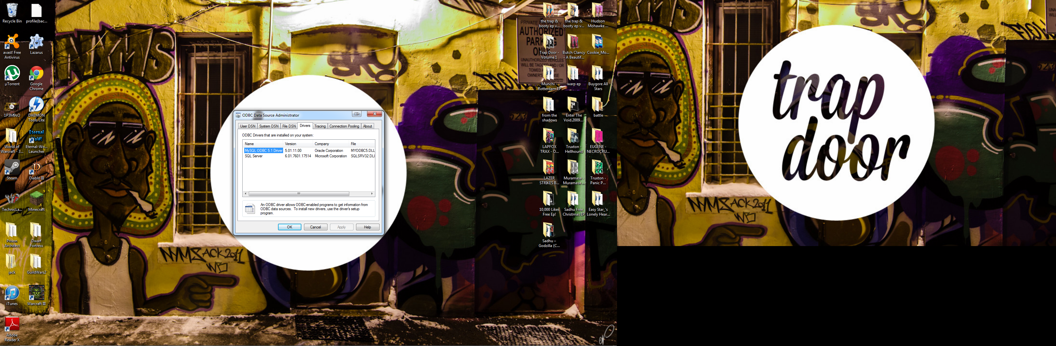

If you click on the drivers tab of the pop-up the mysql driver should be shown as above.

1. Now you click on the User DSN tab as shown

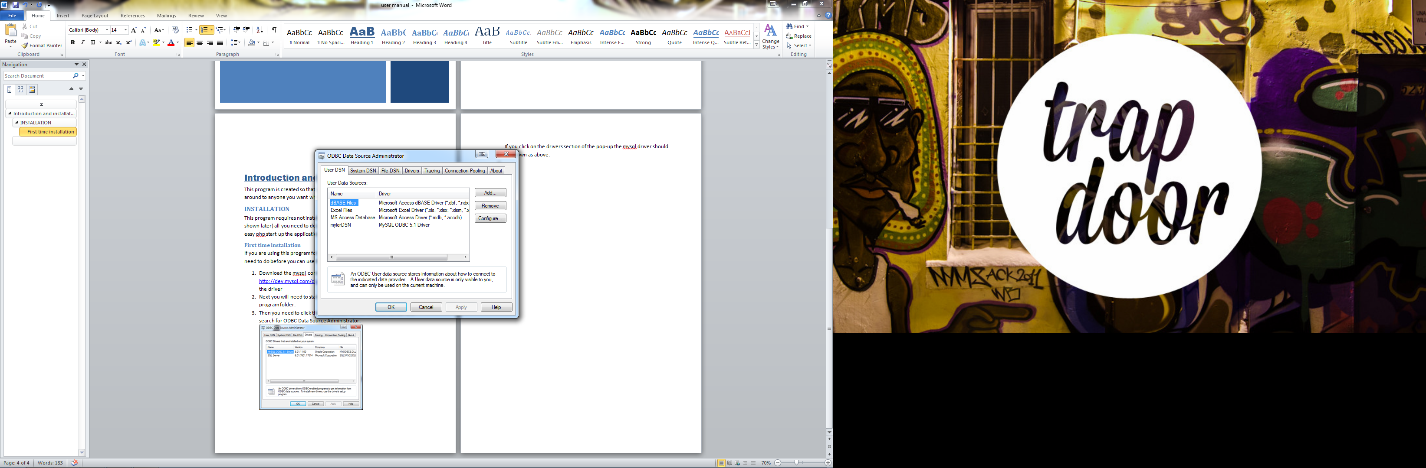

Now click on the Add button

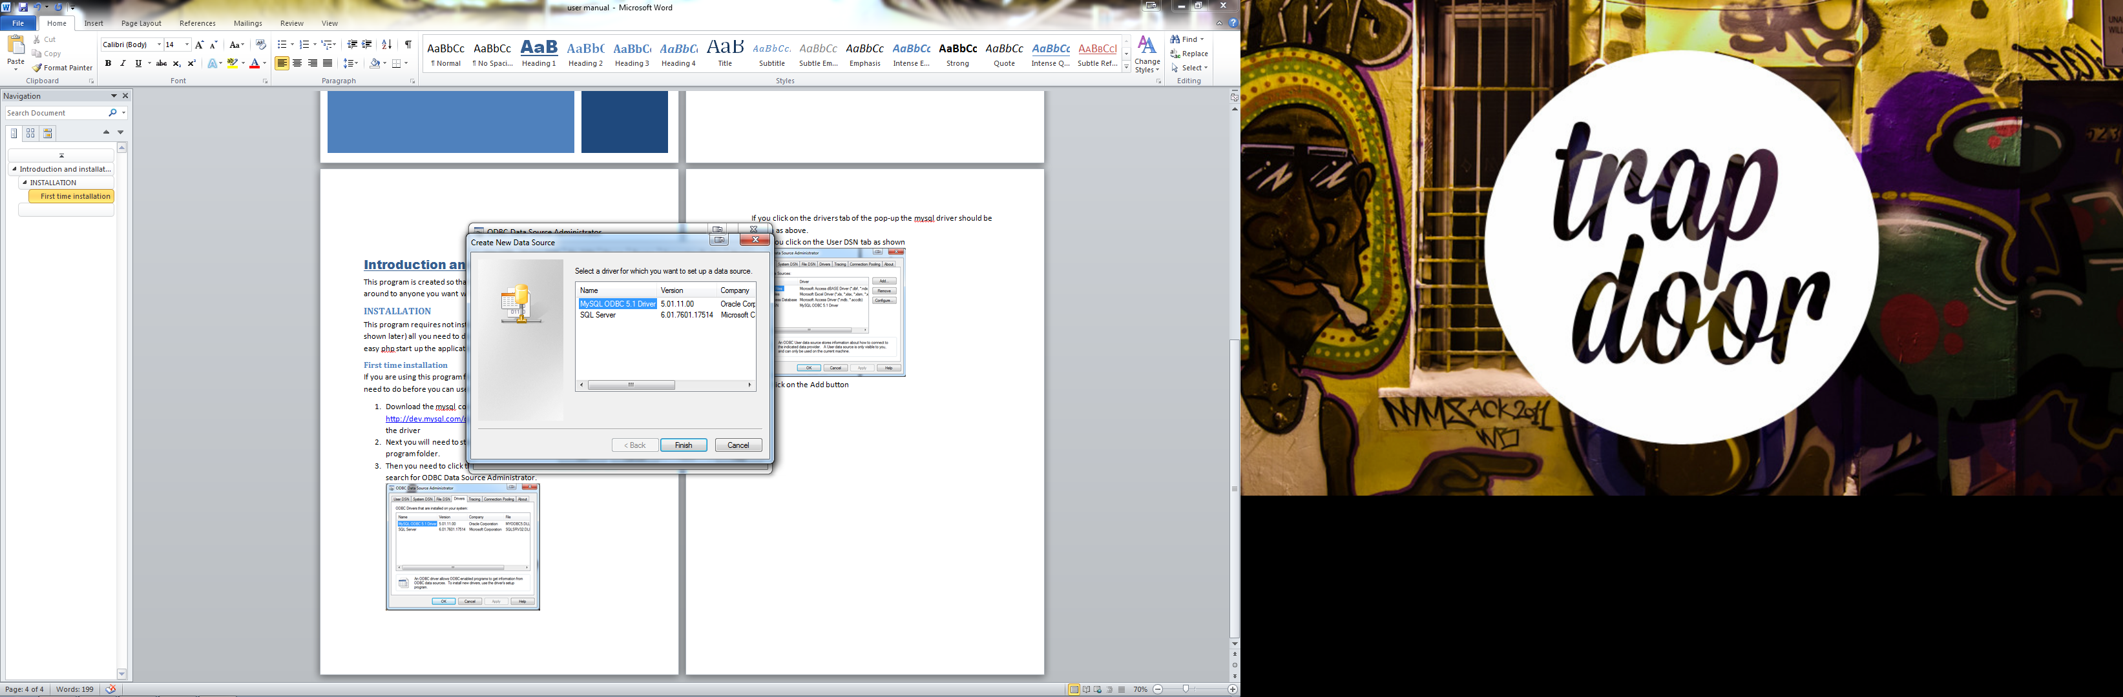

Click on the driver shown above and click finish

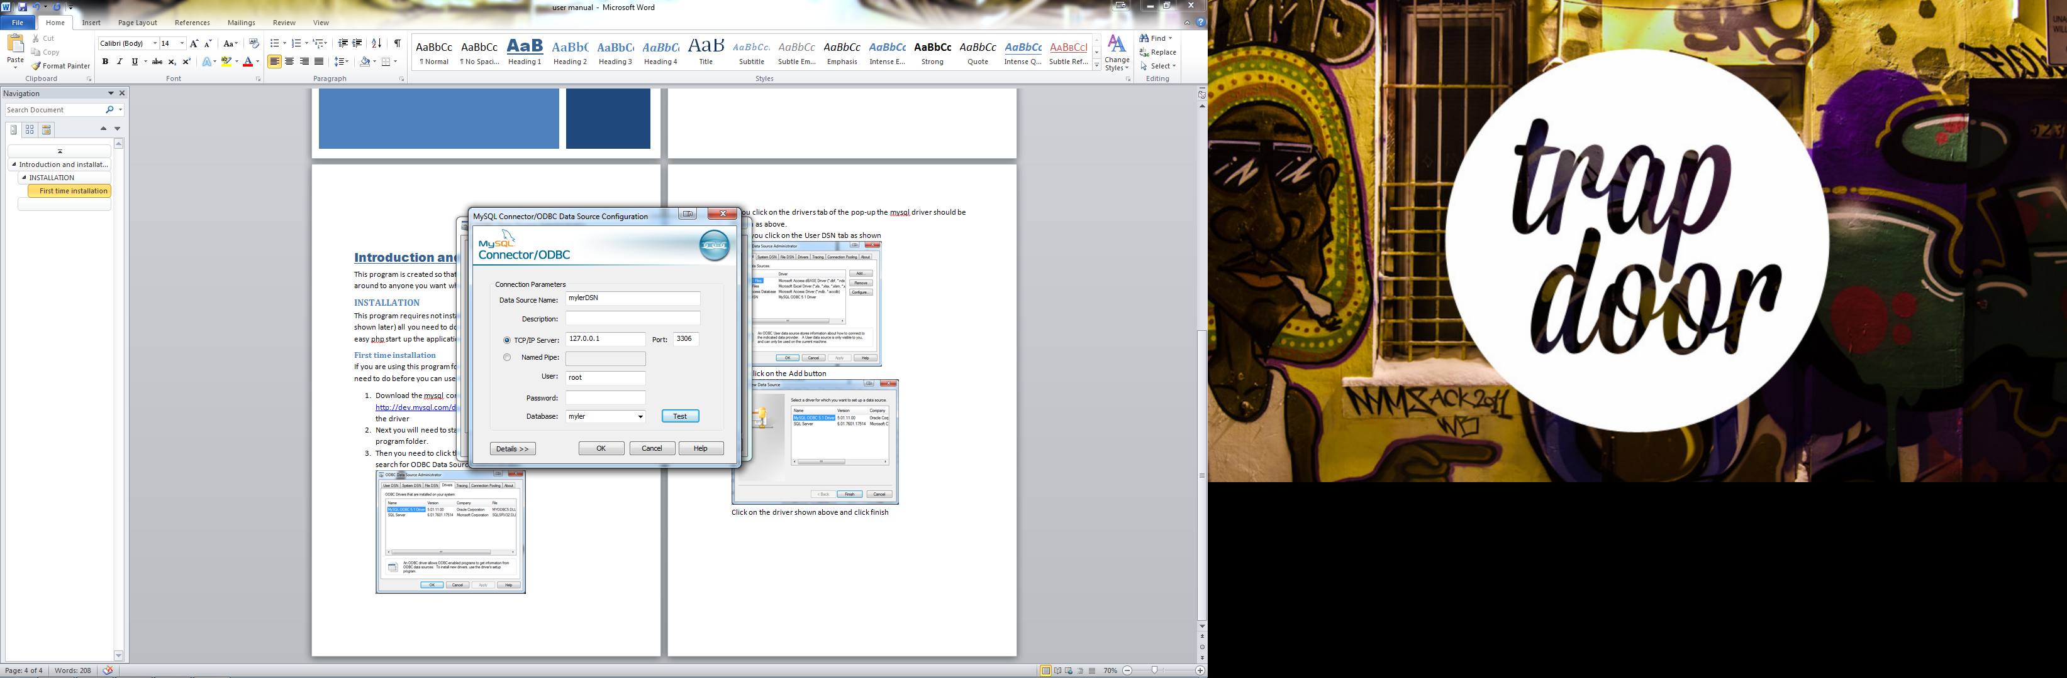

You will be shown this screen with all the boxes blank and all you need to do is fill in the boxes as shown above and click ok.

1. You are now done and can run the program and use it as much as you want.

# How to use the program

## Login and registration

When you run the program you are prompted with this screen.

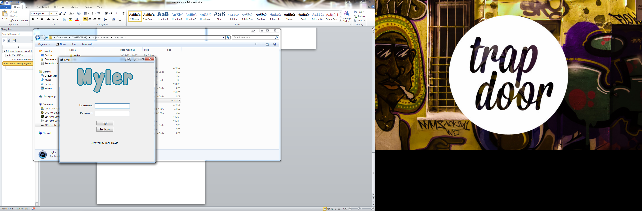

This is the login screen where you put in your login details to access the program. If you do not have any login details then you will be required to register yourself. To do this you need to click on the register button. This will show the screen below.

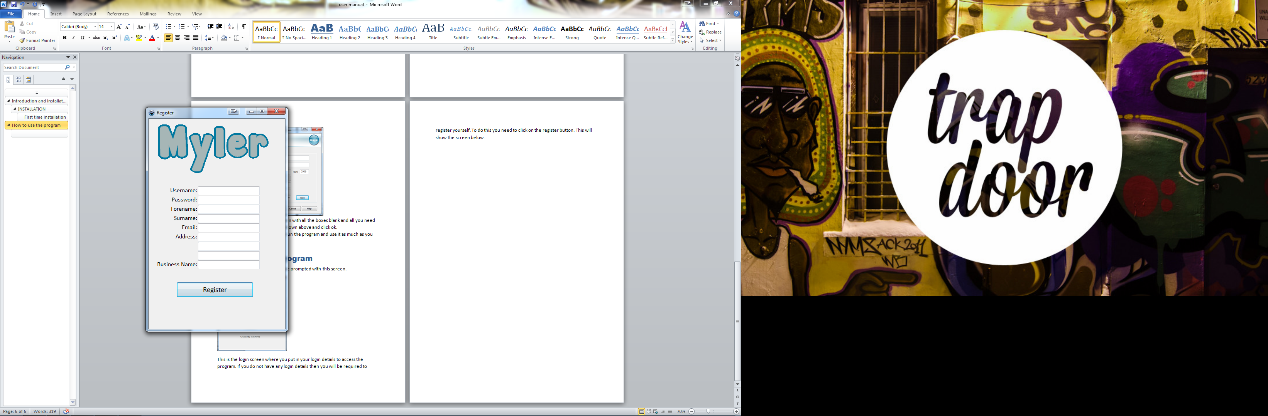

This is the register page and to register you will need to fill in your details and click the register button. You will then be taken back to the login screen where you can fill in your login details and access the program.

## Creating and viewing a flyer

After you have logged in you will be shown this screen. This is the main screen.

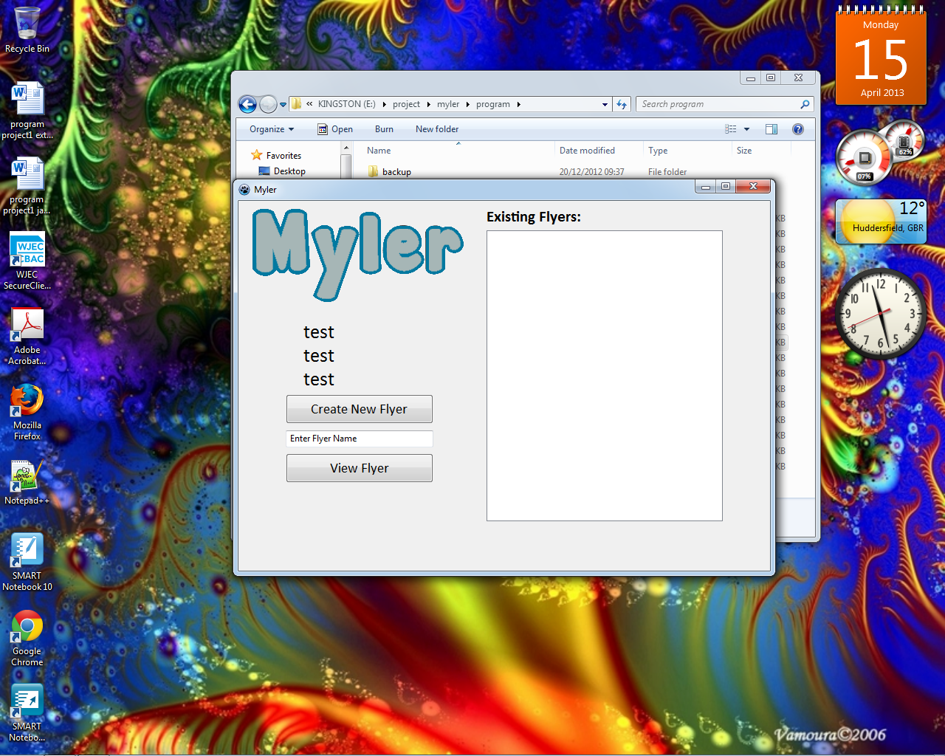

From this screen you can create a new flyer by clicking the Create New Flyer button or view a flyer by entering the flyer name to the box and clicking the view flyer button.

### Creating a flyer

If you click the Create New Flyer you will be shown the screen below.

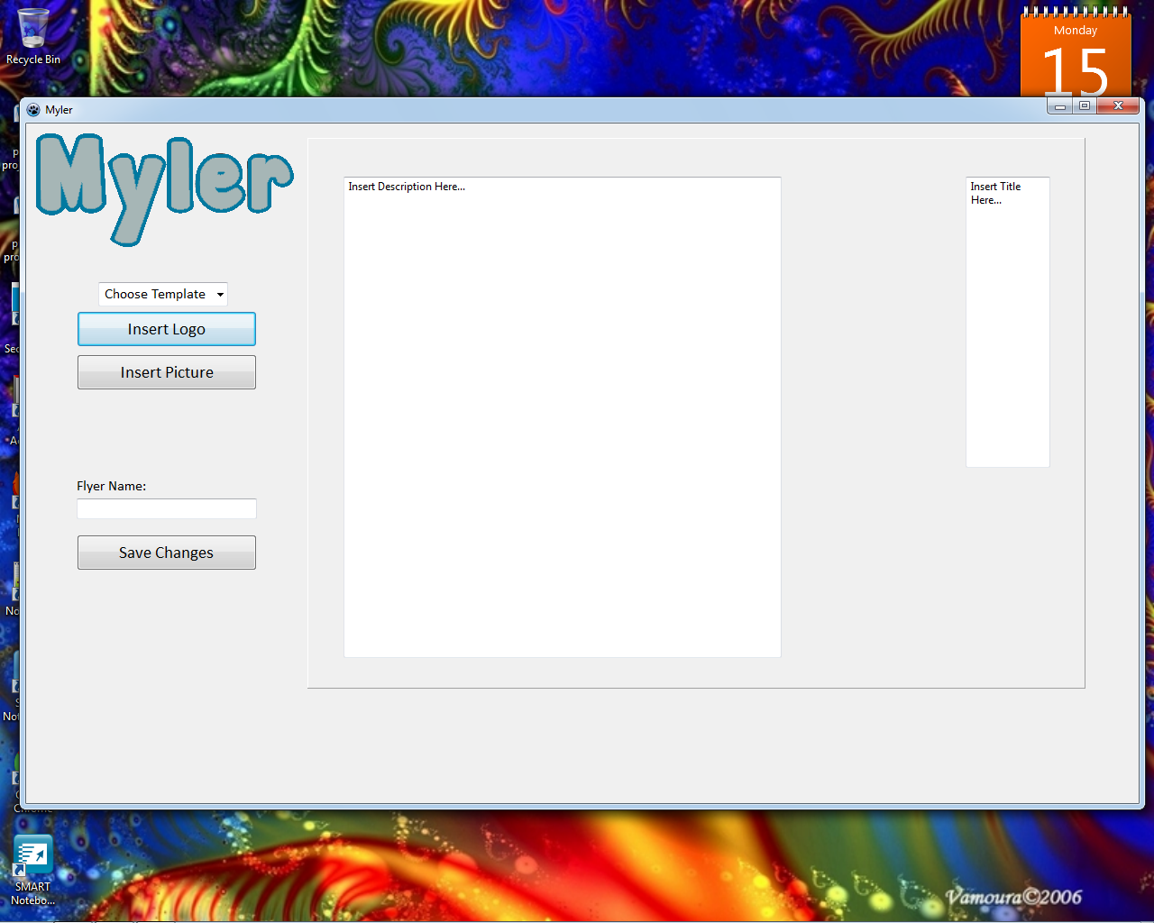

From this screen you can create your own flyer. There are customisable options on the left for example changing the template will change the layout and background colour of the flyer and the buttons when clicked will load a picture into the appropriate position and you can enter your text on the boxes in the panel. When you have finished creating your flyer you need to enter the name of your flyer and click the Save Changes button.

### Viewing a flyer

If you want to view a flyer all you need to do is add the flyer name to the box on the main page and click the View Flyer button. For example if you entered “animals” you would be shown the flyer below. 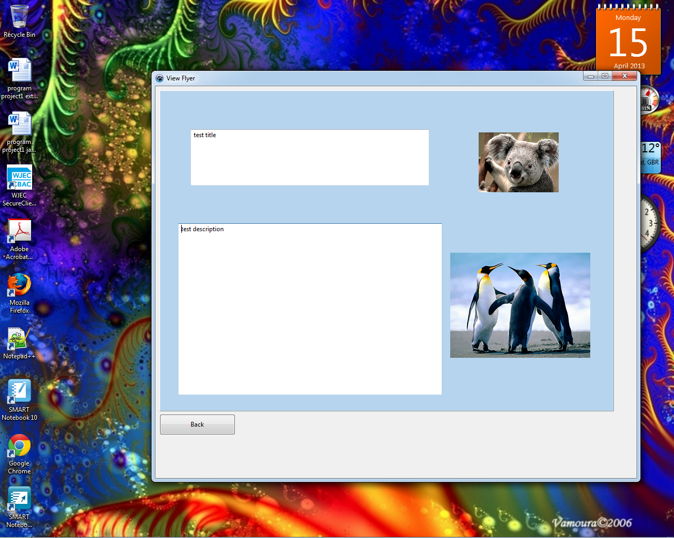

And that’s basically all you need to know to use MYLER.